PROJECT TITLE

METHOD STATEMENT FOR
MIVAN SHUTTERING WORKS

0
Revision | Date | Prepared by | Checked by | Approved by | Remarks

Revision | Revision History
0 | First issue

CONTENTS
Page
Cover 1
Contents 2
- Purpose 3
- Scope of work 3
- References 3
- Materials & Components 3
4.1 Wall Components 3
4.2 Beam Components 5
4.3 Deck Components 6
4.4 Other Components 8
- Material delivery and storage 9
- Manpower 9
- Safety precautions 10
7.1 Hoisting Precautions 10
- Responsibilities 10
- Equipment and Tools 10
- Typical Slab and Wall arrangement – Figure 11
- Work Procedure 11
11.1 Assembly of works 11
11.2 Illustrative Example – Figure 14
- Inspection and Acceptance 15
- Concreting 15
- Dismantling 15
- Inspection Checklists 17

1. Purpose
The purpose of this document is to detail the Procedure for MIVAN shuttering works as per the approved details. The documentation will apply to all Engineers, Workmen, QC personnel and other concerned persons associated with the work.
2. Scope of work
This Procedure covers plant and tools, manpower requirements erection/installation works of formworks and quality control to be followed form works in SEPL projects.
The scope of work consists of:
- Storage of materials
- Setting out and Survey works
- Installation of Formworks and supports
- Deshuttering works.
3. References
- Drawings and any other relevant/applicable documents.
- Project technical specifications
- Respective Indian standards
- Inspection and test plan for Concrete work

4.Materials & Components

Material associated with this Procedure is Mivan shuttering formwork approved using in typical floors

The basic element of the formwork is the panel, which is an extruded aluminum rail section, welded to an aluminum sheet. This produces a lightweight panel with an excellent stiffness to weight ratio, yielding minimal deflection under concrete loading. Panels are manufactured in the size and shape to suit the requirements of specific projects. The panels are made from high strength aluminum alloy with a 4 mm thick skin plate and 6mm thick ribbing behind to stiffen the panels.
4.1 WALL COMPONENTS
1) Wall Panel: - It forms the face of the wall. It is an Aluminium sheet properly cut to fit the exact size of the wall.

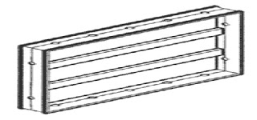
FIG 4.1 WALL PANEL

2) Rocker: - It is a supporting component of wall. It is L-shaped panel having allotment holes for stub pin.

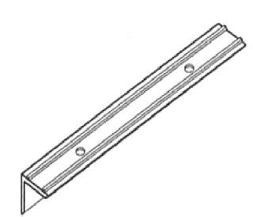
FIG 4.2 ROCKER
3) Kicker: - It forms the wall face at the top of the panels and acts as a ledge to support.

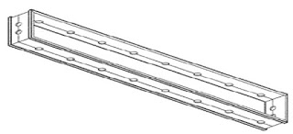
FIG 4.3: KICKER
4) Stub Pin: - It helps in joining two wall panels. It helps in joining two joints.

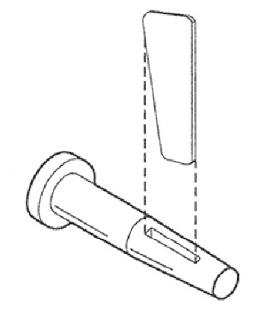
FIG 4.4 STUB PIN

4.2 BEAM COMPONENTS:
1) Beam Side Panel: - It forms the side of the beams. It is a rectangular structure and is cut according to the size of the beam.

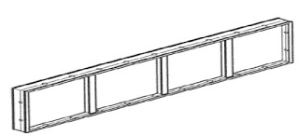
FIG 4.5 BEAM SIDE PANEL
2) Prop Head for Soffit Beam: - It forms the soffit beam. It is a V-shaped head for easy dislodging of the formwork.

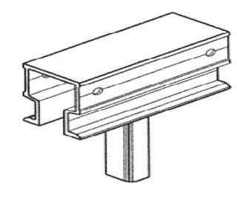
FIG 4.6 PROP HEAD FOR SOFFIT BEAM.
3) Beam Soffit Panel: - It supports the soffit beam. It is a plain rectangular structure of aluminium.
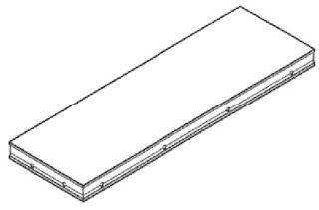
FIG 4.7 BEAM SOFFIT-PANEL

4) Beam Soffit Bulkhead: - It is the bulkhead for beam. It carries most of the bulk load.
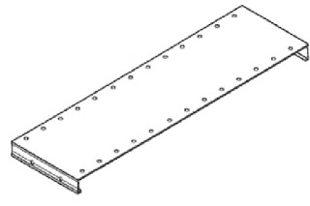
FIG 4.8 BEAM SOFFIT BULKHEAD
4.3 DECK COMPONENTS
1) Deck Panel: - It forms the horizontal surface for casting of slabs. It is built for proper safety of workers.

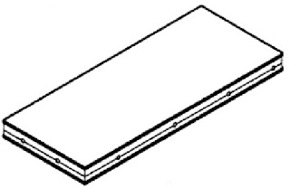
FIG 4.9: - DECK PANEL
2) Deck Prop: - It forms a V-shaped prop head. It supports the deck and bears the load coming on the deck panel.
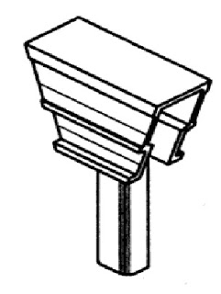
FIG 4.10 DECK PROP

3) Prop Length: - It is the length of the prop. It depends upon the length of the slab.
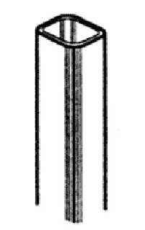
FIG 4.11 DECK PROP LENGTH

4) Deck Mid – Beam: - It supports the middle portion of the beam. It holds the concrete.
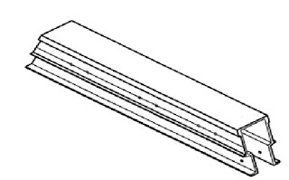
FIG 4.12 DECK MID-BEAM
5) Soffit Length: - It provides support to the edge of the deck panels at their perimeter of the room.
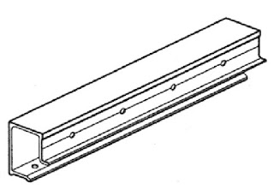
FIG 4.13 SOFFIT LENGTH

6) Deck Beam Bar: - It is the deck for the beam. This component supports the deck and beam.
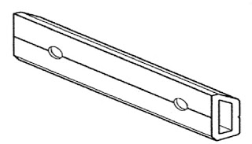
FIG 4.14 DECK BEAM BAR
4.4 OTHER COMPONENTS
1) Internal Soffit Corner: - It forms the vertical internal corner between the walls and the beams, slabs, and the horizontal internal cornice between the walls and the beam slabs and the beam soffit.
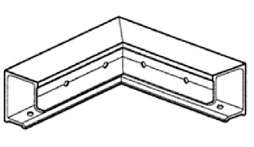
FIG 4.15 INTERNAL SOFFIT CORNER
2) External Soffit Corner: - It forms the external corner between the components
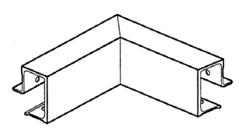
FIG 4.16 EXTERNAL SOFFIT CORNER

3) External Corner: - It forms the external corner of the formwork system.
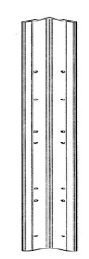
FIG 4.17 EXTENAL CORNER
4) Internal Corner: - It connects two pieces of vertical formwork pieces at their exterior intersections.
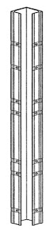
FIG 4.18 INTERNAL CORNERS

5. Material delivery and storage

All Mivan Formowrk shall be delivered as per the project requirements and must be stored in a designated area allotted for the same. Material shall be stored in such a way that the least effort/ distance to shift the materials to the required locations. Meanwhile Contractor can submit a logistic plant for the same.

6. Manpower
Project Engineer, Site Engineers, Supervisors, Foreman and helpers.

7. Safety Precautions
Safety of the personnel and properties is to be given prime importance and all works to be carried out without causing any accidents or property damanges. Activities associated with the Mivan formwork are
- Storage
- Transportation
- Installation and fixing
- Shifting of formwork to the site
- Removal of work
Adequate access and egress shall be provided in the site for carrying out the work in a safe manner. All personnel shall wear basic personnel protective equipment. All the tools, tackles, equipment being used for the works shall be in good working condition and well maintained.
- Only authorised person shall handle the activities.
- Daily toolbox talks with workers involved with Mivan shuttering works.
- Use of proper handrails, edge protection and safety nets for the works in external walls and peripheries.
7.1 Hoisting Safety
- There must be professional personnel in tower crane to coordinate work.
- Check the wire rope strengthened or not.
- Accessory packages must be hoisted by a dedicated funnel chest for loading and unloading.
- Be sure to use a funnel chest or steel wire net for lifting. Do not hoist directly with our ton
8. Responsibility

The Project Manager/Construction Manager shall be responsible for the overall implementation of this procedure.

9. Equipment and Tools Used

Panel puller, wall tie puller, Steel tape, alignment thread, Auto level instrument, right angle, wire brush, wooden mallet.

10. Typical Wall and Slab Assembly

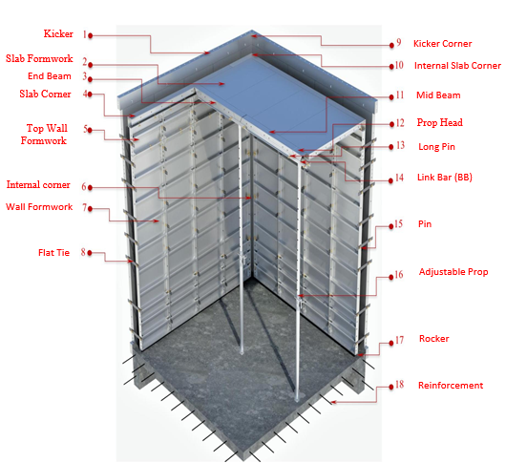

11. Work procedure

The panels are held in position by a simple pin and wedge system that passes through holes in the outside rib of each panel. The panels fit precisely and securely with no bracings required. Activities and resultant works can be proceeded easily with even unskilled labour using hammer being the only tool required with proper supervision. Once the panels have been numbered, measuring is not necessary too. As the erection process is carried out manually, tower cranes are not required other than for shifting.

11. 1 Assembly Work

Levels & Marking
a) Before pouring the concrete on the upper layer, place the formwork thickness control pieces at the root of the shear wall. The first row of control pieces should not be more than 100mm from the main reinforcement of the shear wall, should not be more than 300mm from the internal corner, and the spacing of control pieces should not be more than 2m, to ensure the flatness of the root of the shear wall and avoid the concrete ground unevenness during the installation of the wall column formwork.

b) Set the wall control line at 300mm outside the walls and columns according to the main control line. After the control line of the wall is set and all the control lines are checked and confirmed, the wall column edge line is popped out through the wall column control line. The wall column edge line tolerance must within 2mm.
c) After the concrete casting of the floor, do the positioning rebar at the 50mm-100mm height of wall reinforcement from the floor level, The length of the positioning rebar is determined by the wall thickness. The tolerance between the rebar and the wall control line should be less than 2mm to ensure the wall thickness of the lower part of the shear wall when the formworks is installed.
d) After concrete casting is completed，Mark the 1-meter level line on each shear wall steel bar with each shear wall corner side steel with a levelling point，The wall length over 3 meters must be added a levelling point in the middle of the wall. Spacing of each level point is 1.5m~2m for the inspection of floor height, At the same time, marking 1m line on the support of the slab formworks to counter check the floor height.

Application Of Form Release Agent Before the assembling of aluminium formworks, a form release agent of approved make is to be applied all over the surface where the concrete comes into contact with. Recoating is necessary if the panel remains exposed to extreme climate for a prolonged time such as rain, or dusty etc.
Wall Formwork Assembly: The inner wall formwork installation starts from the inner corner and extends to both sides according as per the numbering/sequence provided in the drawings. Temporary diagonal supports with wood square, steel pipes shall be used fix the same temporarily in order to avoid the chances of falling. The flat-tie should be installed together with the internal wall formwork.
Once the initial wall corner formworks are assembled, commence to erect simultaneously the balance of wall formworks from either side of the internal wall formworks.
Then proceed to assemble the external wall corner. Place these form works into the correct position on the lines which were set up by the surveyor. Proceed to assemble the balance of external wall at both sides.
The vertical formwork is generally nailed by one set of pin & wedge at 300mm intervals, and the horizontally stitched formwork end pin must be nailed. The pin is placed from top to bottom to avoid shaking when vibrating the concrete and the internal and external walls are to be held together by Flat-Tie.
The sequence of the pins installation: The pins of wall panels should be installed from the first hole at bottom and the space of each pin from the bottom is 50,150,300,600,900,1200,1500,1800,2100, 2250,2350 (Spacing shall not exceed 300mm)
Each pin of slab panel installed, the spacing shall not exceed 300mm irrespective of the panel length. The first pin must be at the hole position of 100mm.

Spacing of each pin of kicker panel installed does not exceed 100mm and the first pin installed at the hole position of 100 mm.

Installation of raking shore: The raking shore (temporary side supports) shall be installed on both sides of the column and wall formwork, the bolts are embedded in advance to serve as the force bearing point of the raking shore base. The spacing of the raking shore shall not be more than 1500mm.

Beam & Slab Formworks Assembly:
After walls has been erected and checked for its plumb as per the drawings, install beam formwork, slab and balcony.
The beam bottom formwork can be pre-assembled on the floor. This would be done as a whole set. Assemble the beam bottom formwork、prop head、inner corner formwork according to the sequence. numbering based on the approved drawing.
Adjust the support to level the beam bottom formwork, proceed with installation of sides of beam. All horizontal connections of pin and wedge shall be fixed from top to bottom to avoid adverse effect during vibration of concrete.
After installation of the inner corner formwork at the top of the wall/beam was completed, Middle Beams and End Beams work can be started. Enough support should be installed below every Middle & End Beam. After this installation of slab formwork shall be commenced as per the details of sequence/numbering. Care shall be given to ensure that all the props to be vertical and tight.
Check all the box outs, provisions of MEP services were done

Kicker Assembly: Kickers are fixed on the external wall formworks in accordance with the required height for the formation of the slab concrete and matching the flat tie notching of wall formwork on the upper layer. Check to ensure that the vertically of the kicker is correctly aligned. The kickers shall remain at its position for the subsequent forming of wall at next floor.
Before installing Kicker, make sure the formwork is clean and brush the formwork release agent. Open 36mm x18mm holes on the kicker and install the kicker screws on the kicker before pouring.

11.2 Illustrative Example

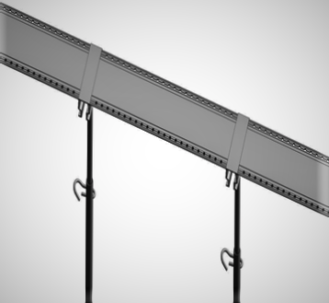  STEP 1 - Adjust the prop to the desired height and connect the beam bottom formwork. | 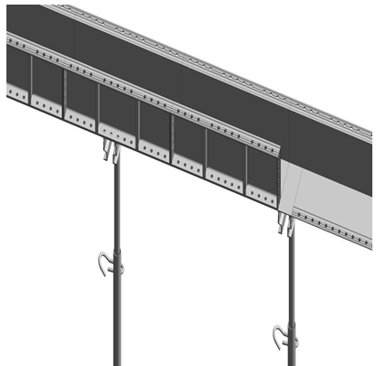  STEP 2 – Connect the internal and external beam side formwork to bottom one.
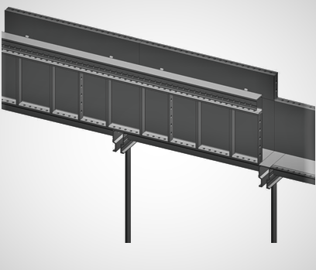  STEP 3 – Connect the external kicker and slab corner formwork onto external and internal beam side formwork. | 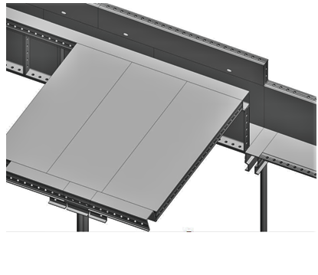STEP 4 – Secure the slab formwork to the slab corner formwork.

12. Inspection and Acceptance:

After the installation the framework shall be inspected for verticality on all wall formworks.
Adjust the supporting prop, control the floor height as and when necessary.
Check the sealing mortar at the base of the wall column before concrete pouring, whether it is closed and dense so to avoid slurry leakage during concrete pouring.
Check whether the top formwork and the beam bottom formwork are horizontal.
Ensure that the bottom of the formwork and the bottom support are vertical and that the support bar is not loose in the vertical direction. And also check that the square and oblique supports of the wall and column formwork are correct.
Check that the pull tabs, pins, and wedges remain in place and secure.
Clear the remaining unwanted materials and check for cleanliness again.
Check MEP clearance is signed for box outs, other service installations.
Follow the established inspection procedure.

13. Concreting:

During concreting ongoing, two workers are to be assigned for checking the connection of pins on both sides of the wall. Spirit level (perfectly working with the bubble showing the correct readings on a plane) can be used for the verticality of walls and columns.
In the process of external wall concrete pouring, the concrete slurry seeping from the bottom of external wall formwork need to be cleaned to ensure that there is no concrete slurry bonding on the external wall.
Care should be given to pins are not get loose and drop out due to vibration and to ensure that all the supports remain in good condition.

14. Dismantling:
Wall Formwork Dismantling

Remove wall columns side formwork: Under normal condition, after 12 - 16 hours of concrete pouring, the side formwork of the wall and column can be removed, firstly, the raking shore is to be removed, then the hollow section, the pins connected with the formwork, and then gently pry the formwork with a crowbar, so that the formwork get apart from the wall. Removed formwork and accessories need to be cleaned up in time. Move to the upper layer same position and fold it up. For the external wall section, the kickers on the upon portion of the floor level shall remain intact to support and align the next level/floor of formwork that are going to be assembled.

Beam & Slab Formworks Dismantling

Deck formwork dismantling start from beam, deck formwork prop position. Remove the pin of beam and deck formwork support and other connective structures. Next, remove the pins of the adjacent beams and formwork, and then remove the formwork, pry it down from the junction of the formwork and concrete with a crowbar, and ensure that the support remains as the original and does not loose. Removed formwork and accessories need to clean up in time. Move to the upper layer same position and fold it up.
Remove support: 2-3 sets of prop stands will be provided from GETO to support the slab in order to ensure safety, ensure the suspended formwork, will not deformation, each supporting of the three floors can be rotated.
The formwork removed on the site shall be sorted and cleaned and shall be trimmed and repaired in time to avoid slab become overweight to reduce the workload of the later cleaning formwork. The place where the cleaned formwork is placed shall be flattened with a raft to prevent deformation of the formwork.

Flat Tie Dismantling
One-time Flat Tie and Reusable Flat Tie used for the purpose of ensuring that the thickness of walls and column are consistent are to be removed by using special tools after the wall formworks dismantling.

15. Inspection Checklist
PROJECT NAME
INSPECTION RECORD
MIVAN FORMWORK INSTALLATION

Level |  | Inspection Number | QA- -XXX-MIV- _______ | Applicable  Dwg: #

Location/Element |  | Prepared By

# | Description | Result | Date | Sign Off
 |  |  |  | Contr | Inspector
1 | Formwork surface is cleaned, and shuttering oil applied
2 | Internal and external wall and column alignment adjusted
3 | Internal and external wall and column verticality adjusted
4 | Support and hollow section installed as per details
5 | Flat ties and PVC sleeves are provided accordingly
6 | Door and window openings are provided as per drawing
7 | Sides are true vertical for the above.
8 | Pin and Wedges installed as per the details
9 | Gaps elsewhere in all places are closed properly
10 | Staircase thread and risers were properly secured
11 | Staircase supports and props are as per the details
12 | Box outs/openings in the slab and beam are provided
13 | All the services as per MEP drawings are provided
14 | Clearance signed off by MEP in charge for points (12,13)
15 | Beam and slab panels are horizontal and in level
16 | All drops and upstands are provided as per drawings

CONCLUSION | Accepted Accepted with Comments Rejected
COMMENTS
CONTRACTOR |  |  | SEPL
Date |  | Sign | Date | Sign

